Name: Lab Station # ______ Partner Name: Honors Chemistry

Introduction
Chemical changes are changes in chemical bonds. The identity of a substance changes in a chemical reaction. You can usually recognize a chemical change by seeing evidence of this new substance. Evidence includes 1) color change, 2) formation of a precipitate, 3) production of gas (bubbles) or 4) sound, 5) change in temperature or 6) odor, 7) release of energy in the form of heat or light.

The Law of Conservation of Mass states that in a closed system matter cannot be created or destroyed. The sum of mass of the reactants must equal the sum of the mass of the products.

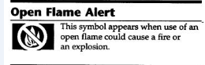
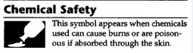
Safety
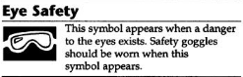

Materials
- 2- 150-mL beakers 1M hydrochloric acid
- graduate cylinder 0.1M potassium iodide solution
- watch glass 0.1M lead nitrate solution
- evaporating dish ethanol, (ETOH)
- pipette hydrogen borate
- scoopula marble chips
- lighter stick steel wool

Pre-lab Questions
- Paper burning is a chemical change. How do you know this?

- After burning, the mass of the paper has changed. Does this violate the Law of Conservation of Mass? Explain

Procedure
EXPERIMENT 1
- Obtain two 150-mL beakers. Label as Beaker A and Beaker B.
- Add 10.0 mL of lead nitrate to Beaker A.
- Add 10.0 mL of potassium iodide to Beaker B.
- Place both beakers on the balance together and record total mass of beakers and chemicals.
- Pour contents of Beaker A into Beaker B. Find the total mass of beakers and chemicals. Record mass and observations in Data Table. Dispose of chemicals at Waste Station. Do Not Pour Chemicals Into Sink!
EXPERIMENT 2
- Add approximately 20-mL of marble chips into Beaker A.
- Add 40.0 mL of hydrochloric acid to Beaker B. Place both beakers with substances on balance and record total mass.
- Remove beakers from balance.
- Predict what will happen to mass once they are combined.
- Pour contents of Beaker B into Beaker A.
- Wait two minutes and record total mass and observations. Rinse marble chips with plenty of water and dispose at Waste Station.

EXPERIMENT 3
- Setup a Bunsen Burner.
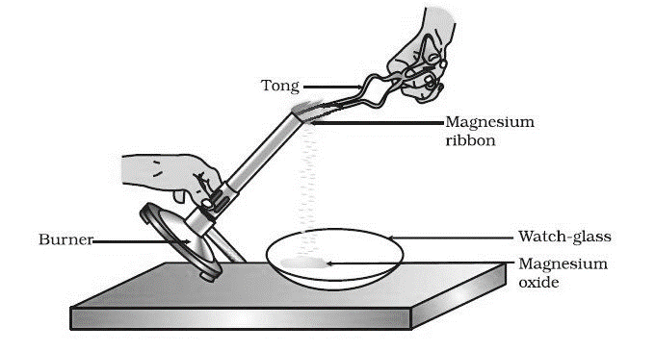
- Find mass of a sample of steel wool and a watch glass.
- Hold steel wool with tongs directly over the watch glass.
- Carefully tilt the Bunsen Burner to heat the steel wool until it glows. Turn the steel wool around in the flame so that all sides are exposed. Any pieces of the steel wool that break free during heating should fall onto watch glass.
steelwool
- Record your observations when the appearance of the steel wool changes. Let it cool for about 1 minute.
steelwool
- Record mass of the heated steel wool (including any parts that may have fallen during heating) and watch glass.
- Dispose of “used” steel wool at the Waste Station.

EXPERIMENT 4
- Add about 5ml of ethanol to an evaporating dish using a transfer pipette.
- Carefully light ethanol using a lighter stick. Record observations. Let evaporating dish cool.
- Again add 5mL of ethanol to evaporating dish.
- Use a scoopula to add a tipful of hydrogen borate to the ethanol. Stir lightly with scoopula.
- Carefully light contents of evaporating dish using a lighter stick. Record observations.
- Let evaporating dish cool, then wash materials using soap/water.

Data Table
NOTE: Any measurements without units are considered inaccurate. Be sure to place units every time.
EXPERIMENT 1
 | Before | After
Total mass of beakers & chemicals
Observations
(color/texture)

EXPERIMENT 2
 | Before | After 2 minutes
Total mass of beakers & substances
Observations

EXPERIMENT 3
 | Before | After
TOTAL Mass of steelwool and evaporating dish
Observations

EXPERIMENT 4
 | Before | After
Calculated mass of 5.0mL of ethanol.
D_{ETOH} = 0.789g/cm³

Observations of Step 2

Observations of Step 5

Data Analysis:
Answer in complete sentences. Each question has a point value. Blank responses will cost double points.
EXPERIMENT 1
- What observations did you make in Experiment 1? Was there a change in mass? (2)

- Based on your observations, how did you determine that a chemical change took place? (2)

EXPERIMENT 2
- What observations did you make in Experiment 2? Was there a change in mass? (2)

- Based on your observations, how did you determine that a chemical change took place? (2)

EXPERIMENT 3
- What observations did you make in Experiment 3? Was there a change in mass? (2)

- Based on your observations, how did you determine that a chemical change took place? (2)

EXPERIMENT 4
- What observations did you make in Step 2&5? How do you know there was a mass change? (2)

- Based on your observations, how did you determine that a chemical change took place? (2)

- Below is the chemical equation for this experiment, but there is a second product. Predict the second product. (Hint look at the bottom of the evaporating dish.) (2)

3C₂H₆O + H₃BO₃ + heat C₆H₁₅BO₃ + 3_______

Conclusion: Answer the following questions using complete sentences.
- How is an OPEN system different from a CLOSED system? (2)

- Describe a situation in which the reactants might weigh more than the products. (note: this is actually impossible!) (1)

- Describe a situation in which the products might weigh less than the reactants. (note: this is also impossible!) (1)

- Write a paragraph which explains 1) how the Law of Conservation of Mass was obeyed in each experiment, and 2) how you tried to prevent determinate error. Be sure include specific evidence for each experiment. (5)

